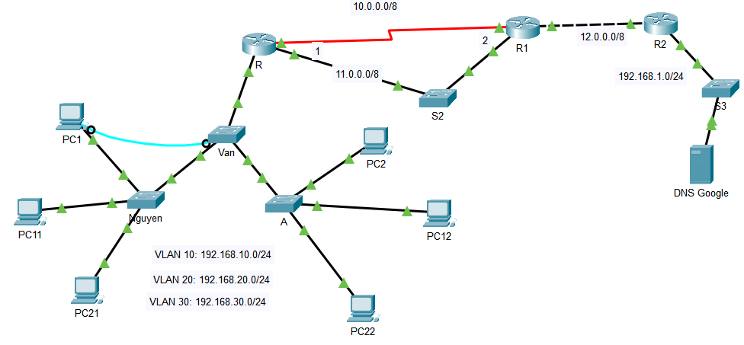

8.8.8.8

1. From the results of Lab 1.1, expand to the diagram as shown above (save file with name FullName_StaticRoute.pkt)

Copy cấu hình của router.

Setup theo ảnh trên.

Setup ip route cho R1

Setup R

Setup R2

DNS google

2. Configure ip address to the devices (ip address is shown in the picture)

3. Configure static route to ping between networks (in which the path from R -> R2: R->S2->R1 is the main route, R->R1 is the backup route)

4. Configure default route at R1 (go out network 12.0.0.0/8) and R2 (go out network 12.0.0.0/8)

5. Test ping from PCs in vlans to DSN google (8.8.8.8)

6. Shutdown interface g0/1 of R and check packets sent from any PC in vlans to 8.8. DSN google (8.8.8.8)

7. Save file with another file name (FullName_RipRoute.pkt and Configure RIP version 2 on router R, R1, R2

8. View routing table on routers (R, R1, R2)